Nombre: _________________________
Match the numbers written out in column one with the numerals in column two. (Write the letter on the line provided)
- ocho _____
- uno_____
- cinco_____
- nueve_____
- tres_____
- catorce_____
- dos_____
- veinte_____
- seis_____
- trece_____
- dieciocho_____
- quince_____
- once_____
- cuatro_____
- diecisiete_____
- diez_____
- doce_____
- dieciséis_____
- diecinueve_____
- siete_____

- 17
- 13
- 20
- 18
- 1
- 10
- 8
- 11
- 4
- 3
- 14
- 6
- 15
- 12
- 5
- 7
- 19
- 2
- 16
- 9
Add and subtract the numbers written in Spanish below, write the answer in Spanish.
- doce – tres= ____________________
- dos + cuatro = ____________________
- once- seis=____________________
- veinte – ocho=____________________
- diecisiete + tres =____________________
- diez + nueve =___________________
- quince + cinco =____________________
- trece- nueve=____________________
- doce - cuatro=____________________
- dieciséis + uno=____________________
- diecinueve - nueve=____________________
- ocho + ocho=____________________
- catorce- trece=____________________
- quince - doce=____________________
- nueve + ocho=____________________

Classroom Vocab
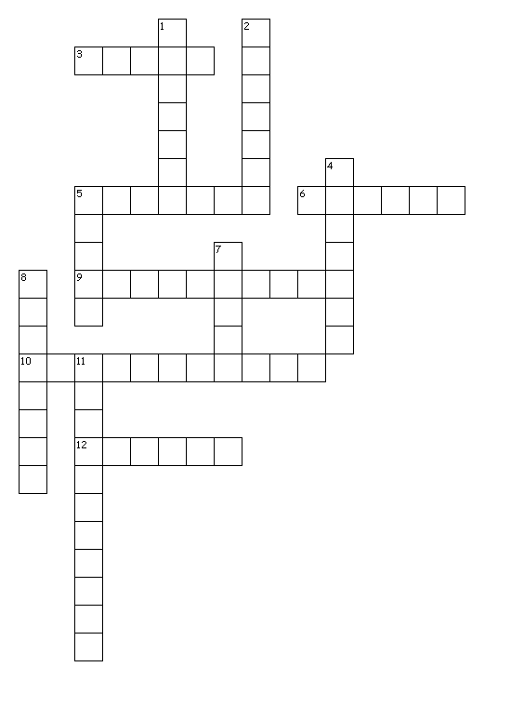

Match the statements in column A with an appropriate answer in column B.
- ¿Quieres un café? ___ A. No, lo siento.
- Gracias.___ B. No, gracias. Prefiero un té.
- ¿Tienes un lápiz, por favor? ___ C. Adiós.
- Hasta mañana.___ D. Sí, por favor. Me gusta el chocolate.
- ¿Quieres chocolate? ___ E. De nada.
Across
3. clock
5. chalkboard
6. poster
9. student
10. dictionary
12. door
Down
1. backpack
2. window
4. flag
5. paper
7. chair
8. notebook
11.computer

