Puerto Rico:
1. CapitalSan Juan
2. Currency U.S. Dollars
3. Common Foods Mofongo and Arroz con habichuelas
4. Flag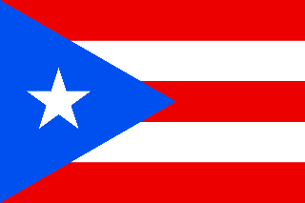
5. Common Tourist Attraction El Castillo San Felipe El Morro
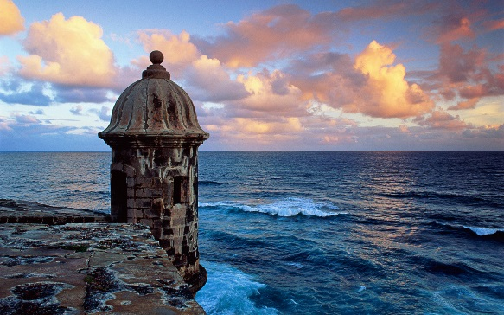
6. McDonaldsSame
_____________________________________________________________________
Guatemala:
1. CapitalLa cuidad de Guatemala (biggest city in Central America)
2. CurrencyQuetzal (Quetzales) Exchange Rate$1 to 7.33 Quetzal
3. Common Foods Jocón y Yuca con chicharrón

4. Flag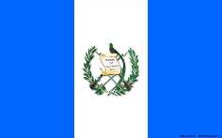
5. Common Tourist AttractionTikal National Park, which are the Ancient Mayan Ruins
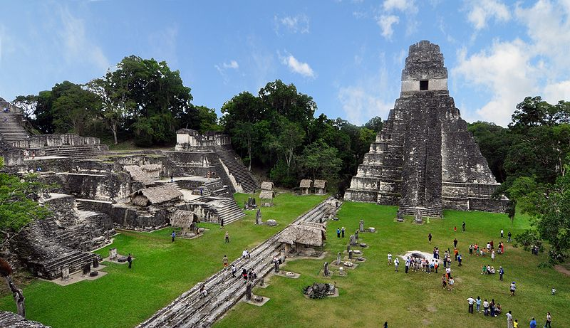
6. McDonalds 43 quetzales for Big Mac Meal

Mexico:
1. Capital La ciudad de México
2. Currency Peso Exchange Rate $1 to 18.84 pesos
3. Common Foodstacos and tameles
4. Flag
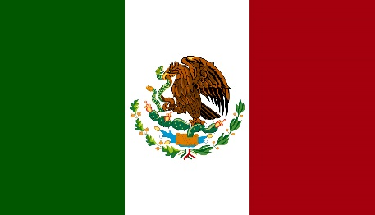
5. Common Tourist AttractionsCancún Underwater Museum
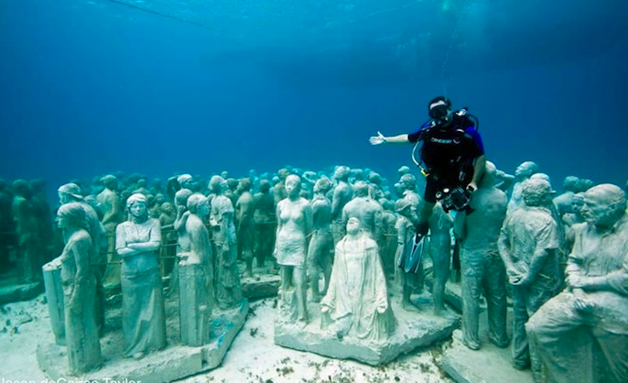
6. McDonalds Big Mac Meal $99 (pesos)= $5.25

