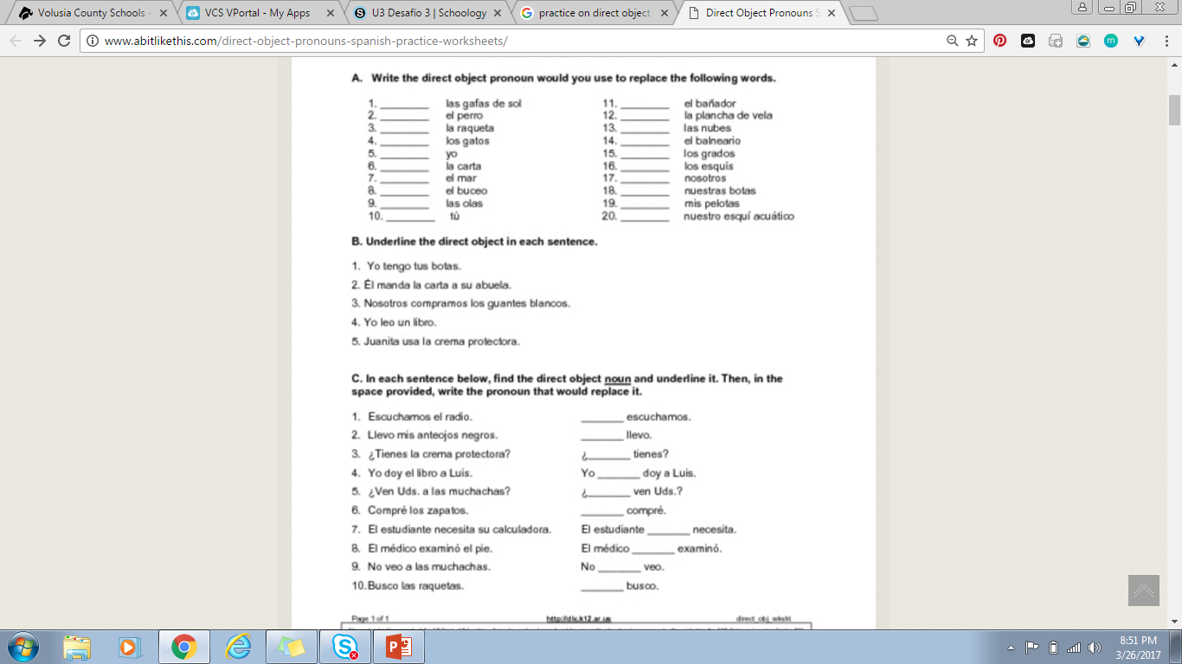

Rewrite the sentence using the direct object pronouns.