Group: _______________________________________________________________________________
Periodo: ____________________ Date: ___________________
Typed Copy: _______
(1)
Vocab Words: _______
(2.5)
Time (between 2-5 minutes) ______
(1)
Written Language:
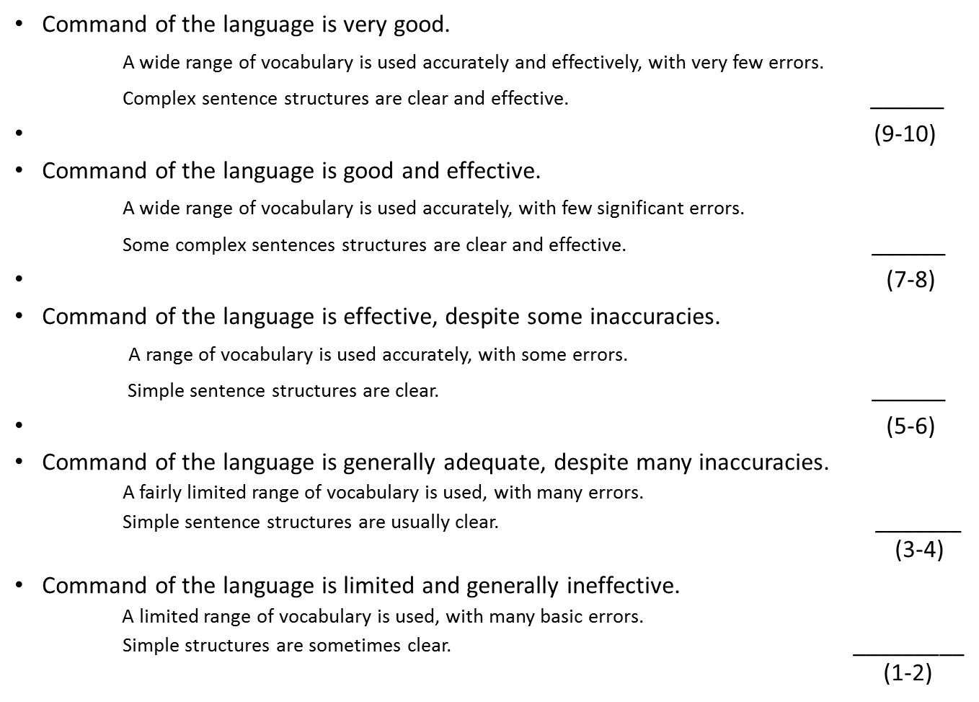
No use of preterite and imperfect
Use of preterite and imperfect used mostly incorrectly.
Use of preterite and imperfect somewhat correctly.
Use of preterite and imperfect used mostly correctly.
Use of preterite and imperfect used correctly.

TOTAL: ____________________
Comments: ____________________________________________________________________________________________________________________________________________________________________________________________________________________________________________________________________________________________________________________________________________________

