Presente Perfecto

In English, the present perfect basically means: __________________________
The formula for the present perfect is: _____________ + ______________

_______________________________
(verbo)

-ar ______________
-er/-ir ___________
Examples:
Have you eaten today?
____________________________________________________________
I’ve travel the world.
____________________________________________________________
We have received your letter.
_____________________________________________________________
Those girls have been putting on makeup for 2 hours!
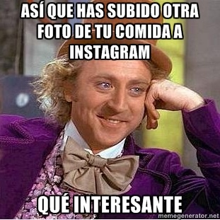
____________________________________________________________

Based on a true story. Only names, dates, and events have been changed.

Irregular Participles Song

Abierto, dicho, descubierto, muerto, hecho, puesto x2
Roto, vuelto, escrito, visto, resuelto x2

Tú has abierto la puerta, you've opened up the door.
No has dicho la verdad, you haven't told the truth anymore.
Tú lo has descubierto, I guess you have discovered.
Que yo no he muerto, I haven't died, dear lover x2
Mira lo que tú has hecho, just look at what you've done.
Tú me has puesto aquí, did you put me here for fun?
Has roto mi corazón, you have broken my heart
Yo he vuelto al principio, I've returned to the start X2
Te he escrito esta carta, I've written you this card
Y has visto mis problemas, you've seen how it's still hard
Yo no he resuelto nada, nothing has been resolved
Me he cubierto con esta manta, I've covered myself in a blanket

